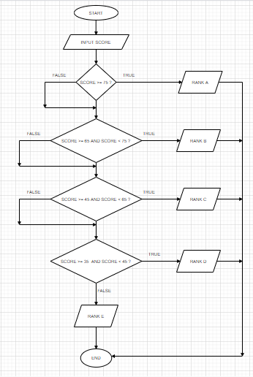

*START*

*INPUT SCORE*

*IF (SCORE >= 75)*

*PRINT “RANK A”*

*ELSE IF (SCORE >= 60 AND SCORE < 75)*

*PRINT “RANK B”*

*ELSE IF (SCORE >= 45 AND SCORE < 60)*

*PRINT “RANK C”*

*ELSE IF (SCORE >= 35 AND SCORE < 45)*

*PRINT “RANK D”*

*ELSE*

*PRINT “RANK E”*

*ENDIF*

*END*